**DAILY ONLINE ACTIVITIES SUMMARY**

|  |  |  |  |  |  |  |  |  |
| --- | --- | --- | --- | --- | --- | --- | --- | --- |
| **Date:** | **13-06-2020** | | | | | **Name:** | **JAIDITHYA** | |
| **Sem & Sec** | **6th B section** | | | | | **USN:** | **4AL17CS118** | |
| **Online Test Summary** | | | | | | | | |
| **Subject** | | **PAP** | | | | | | |
| **Max. Marks** | | **30** | | **Score** | | | **27** | |
| **Certification Course Summary** | | | | | | | | |
| **Course** | Text Analytics 101 [Start Course](https://courses.cognitiveclass.ai/courses/course-v1:CognitiveClass+DV0101EN+v1/jump_to/block-v1:CognitiveClass+DV0101EN+v1+type@course+block@course) | | | | | | | |
| **Certificate Provider** | | | **Cognitive class** | | **Duration** | | | **3hrs** |
| **Coding Challenges** | | | | | | | | |
| **Problem Statement:** 1.Write a C Program to calculate Electricity Bill Given an integer U denoting the amount of KWh units of electricity consumed, the task is to calculate the electricity bill with the help of the below charges: • 1 to 100 units – Rs. 10/- Per Unit • 100 to 200 units – Rs. 15/- Per Unit • 200 to 300 units – Rs. 20/- Per Unit • above 300 units – Rs. 25/- Per Unit Examples: Input: U = 250 Output: 3500 Explanation: Charge for the first 100 units – 10100 = 1000 Charge for the 100 to 200 units – 15100 = 1500 Charge for the 200 to 250 units – 20*50 = 1000 Total Electricity Bill = 1000 + 1500 + 1000 = 3500 | | | | | | | | |
| **Status: solved** | | | | | | | | |
| **Uploaded the report in Github** | | | | | **Yes** | | | |
| **If yes Repository name** | | | | | **Daily status-13th june** | | | |
| **Uploaded the report in slack** | | | | | **yes** | | | |

Online test report assessment screenshot

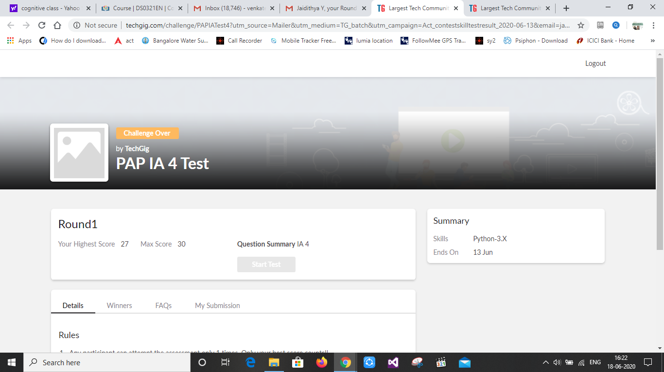

## Certification course details- Text Analytics 101

## C:\Users\Ronith Raddy\Pictures\Screenshots\Screenshot (185).pngC:\Users\Ronith Raddy\Pictures\Screenshots\Screenshot (184).png

Coding Challenges Details- 1.Write a C Program to calculate Electricity Bill Given an integer U denoting the amount of KWh units of electricity consumed, the task is to calculate the electricity bill with the help of the below charges: • 1 to 100 units – Rs. 10/- Per Unit • 100 to 200 units – Rs. 15/- Per Unit • 200 to 300 units – Rs. 20/- Per Unit • above 300 units – Rs. 25/- Per Unit Examples: Input: U = 250 Output: 3500 Explanation: Charge for the first 100 units – 10100 = 1000 Charge for the 100 to 200 units – 15100 = 1500 Charge for the 200 to 250 units – 20*50 = 1000 Total Electricity Bill = 1000 + 1500 + 1000 = 3500

